User Interface Design

Main Screen

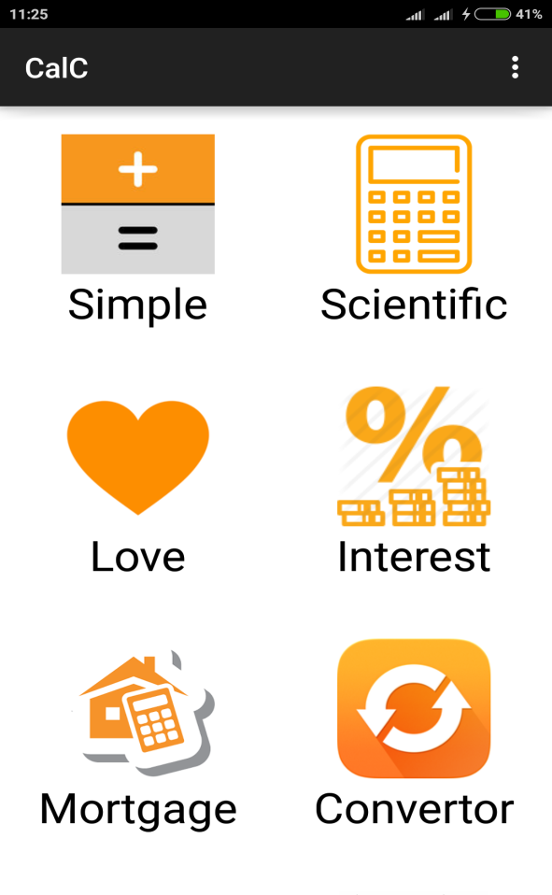 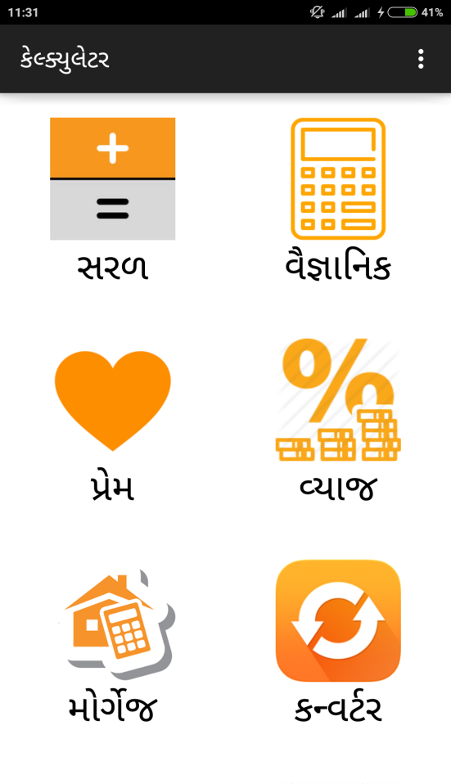

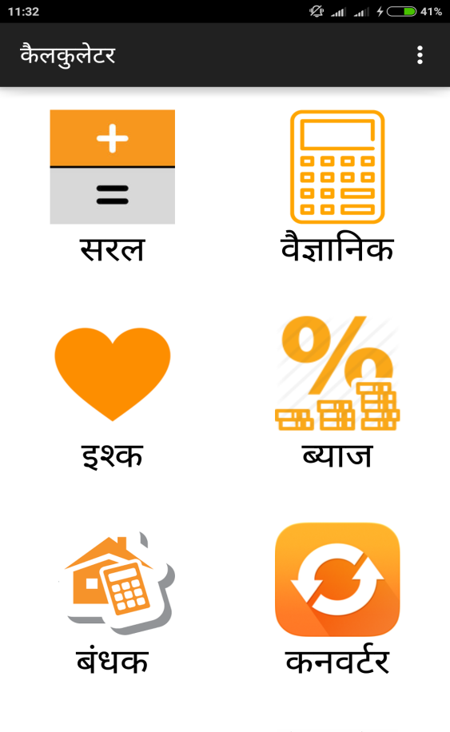

Other Part of the Main Screen

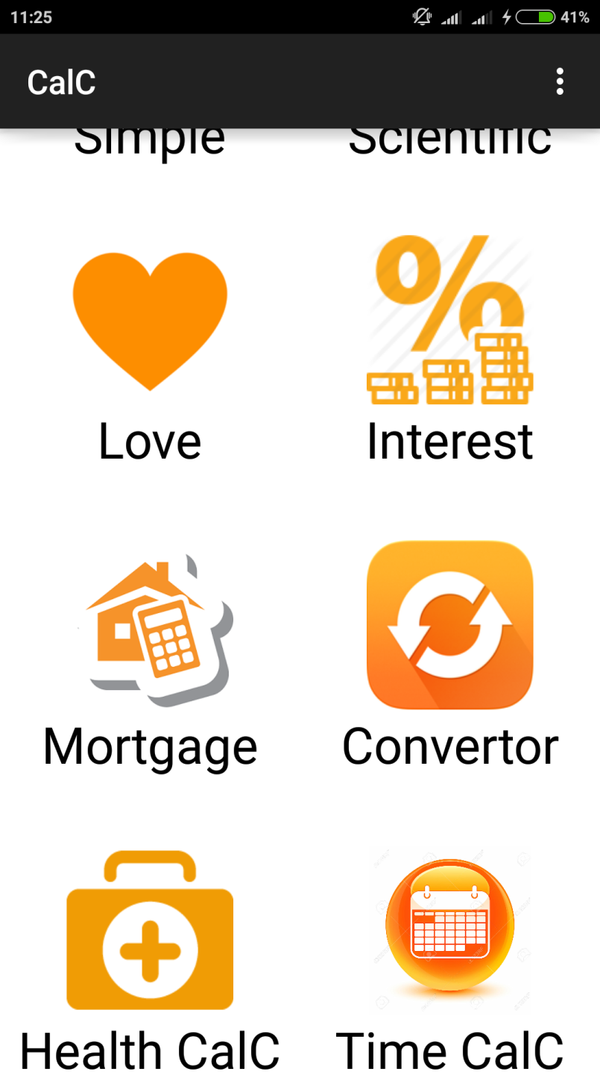

When you open the CalC Application the main page that comes up is shown here.

Simple Calculator

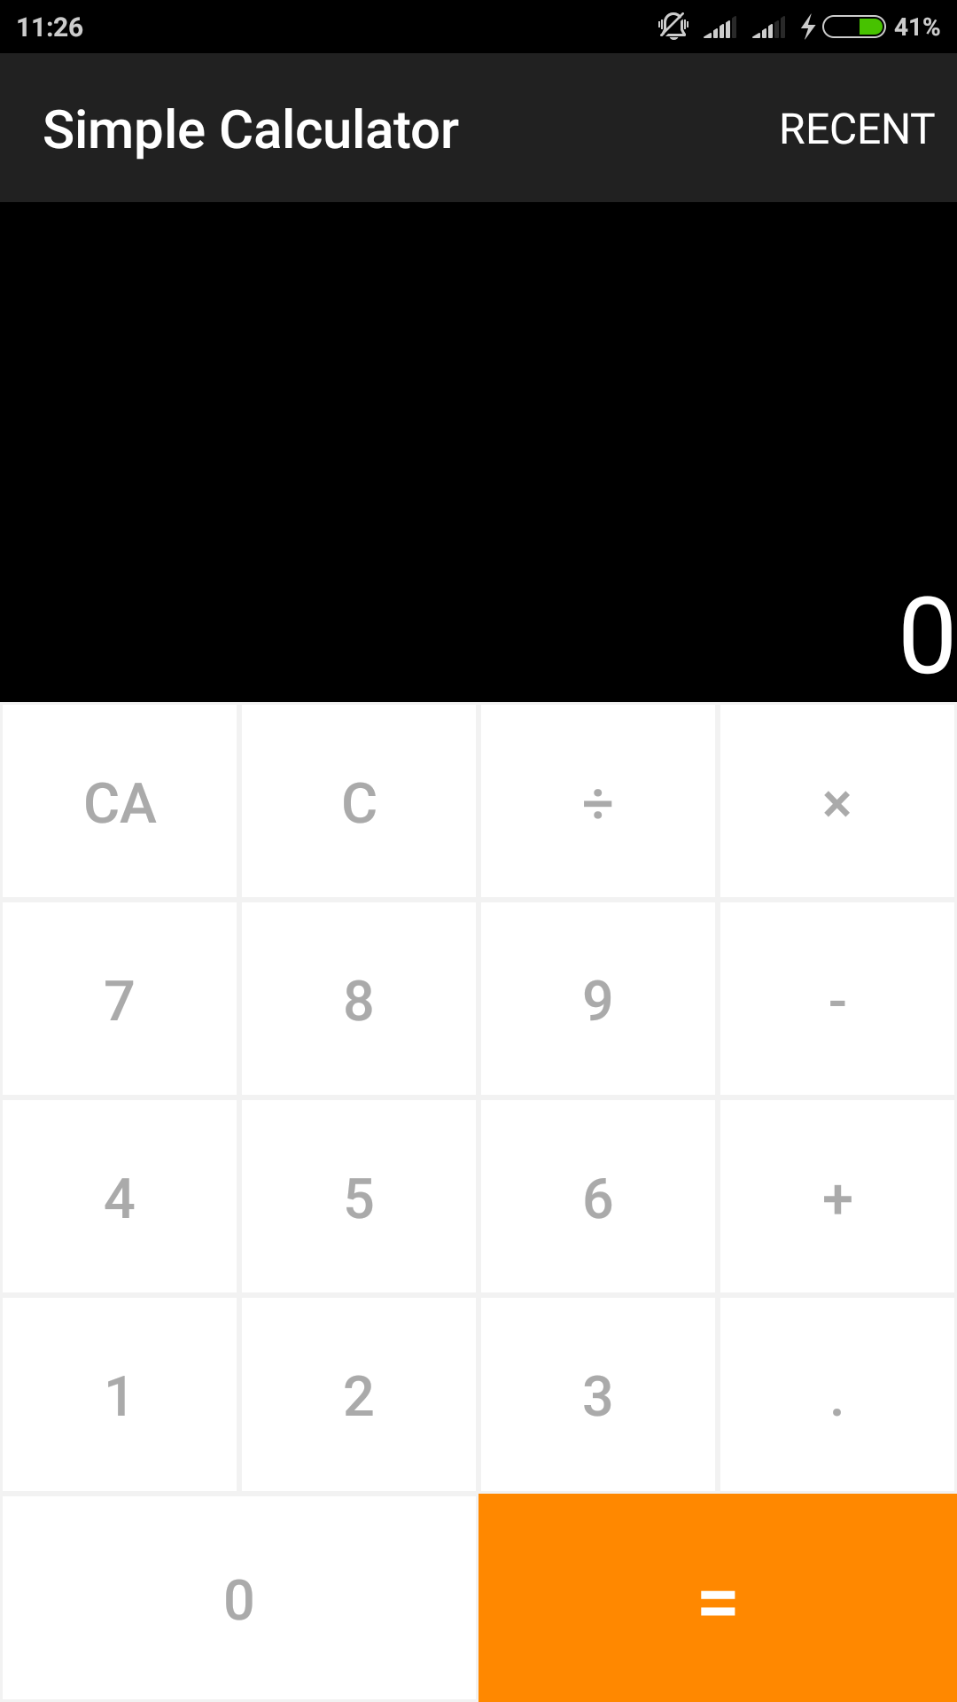

This Page is the layout of the simple calculator which can be opened by clicking on the simple calculator icon.

Simple Calculator Recent Transactions

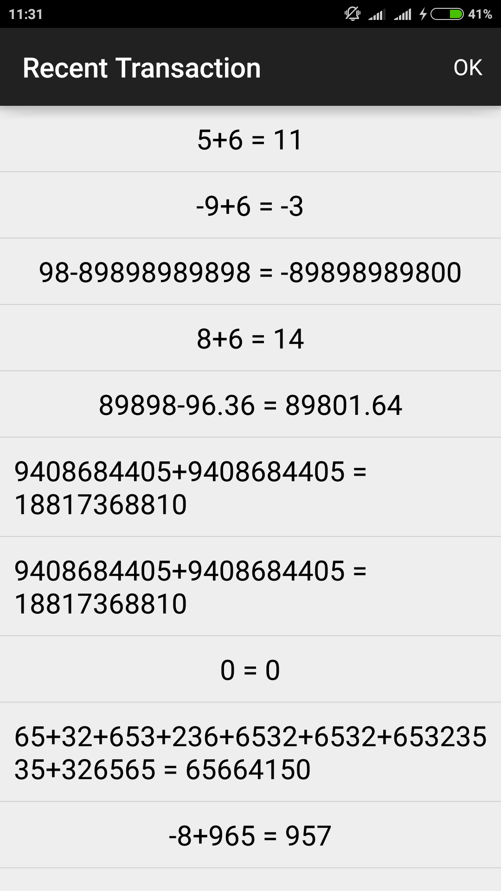

This page shows the recent calculations that are done in the simple Calculator.

Scientific Calculator

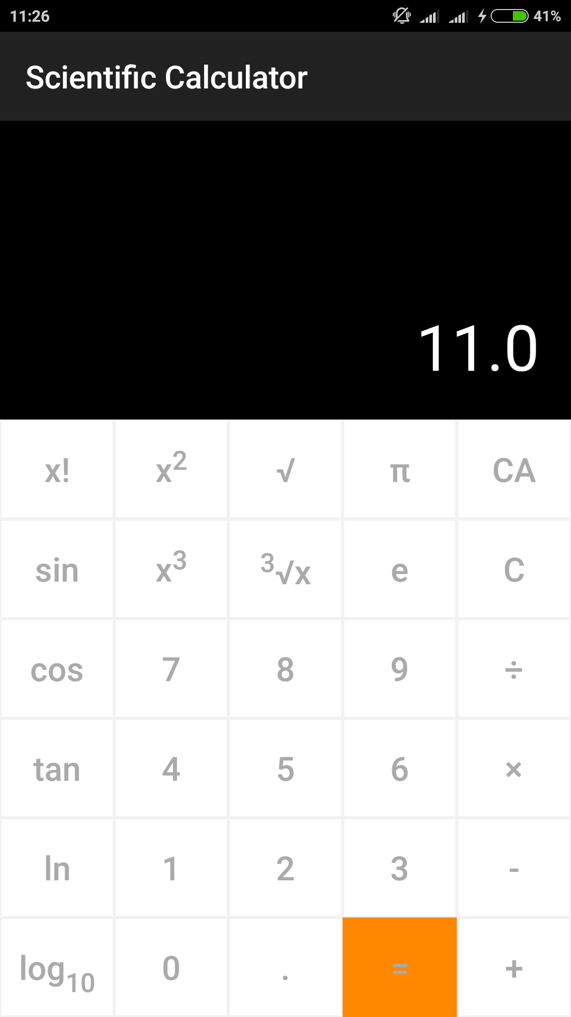

This is the portrait mode of the scientific calculator that can be opened by clicking on the scientific calculator.

Scientific Calculator landscape Mode

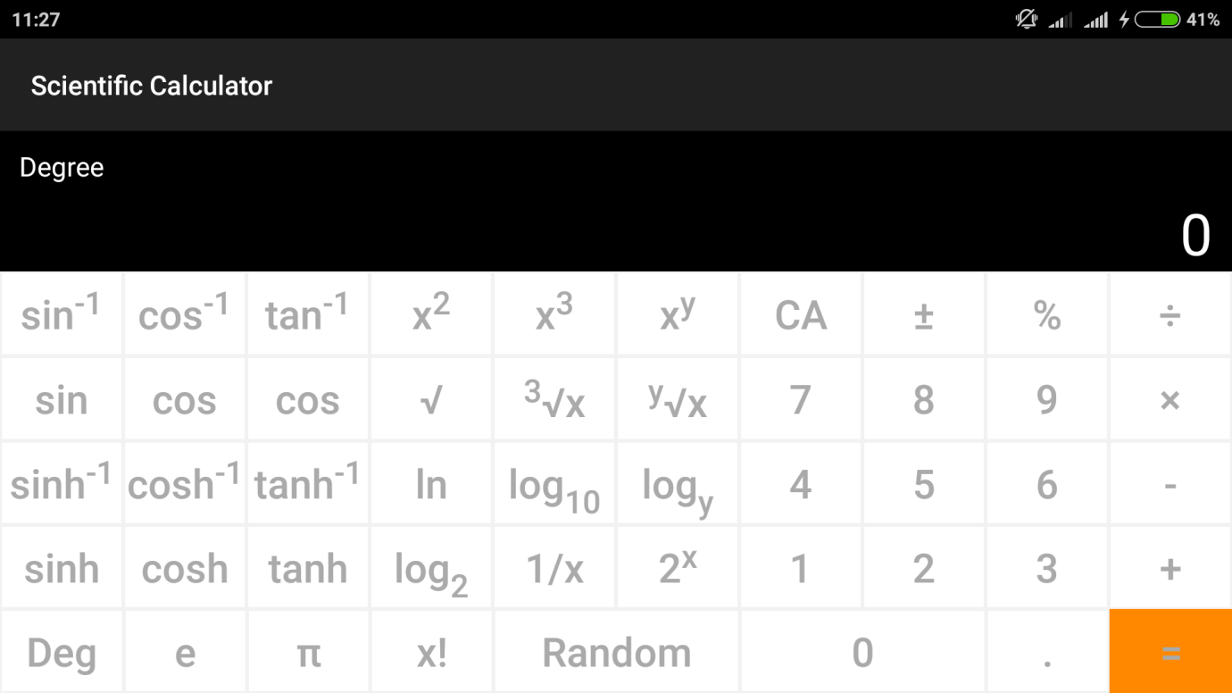

This layout is the landscape mode of the scientific calculator which can be opened by moving the mobile device into horizontal mode. This layout has more functionalities compared to the portrait mode.

Love Calculator

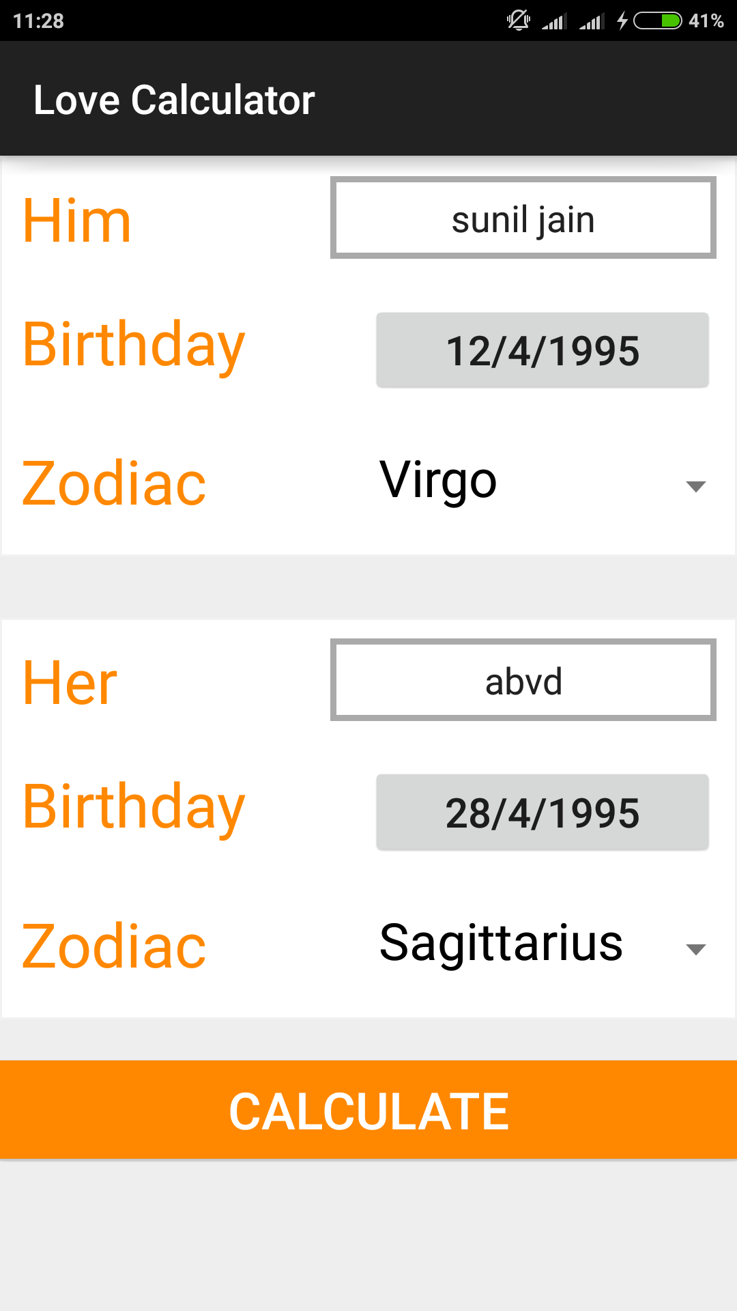

This is the layout of the Love calculator after the splash screen which can be opened by clicking on the love calculator icon in the home screen.

Love Calculator Output page

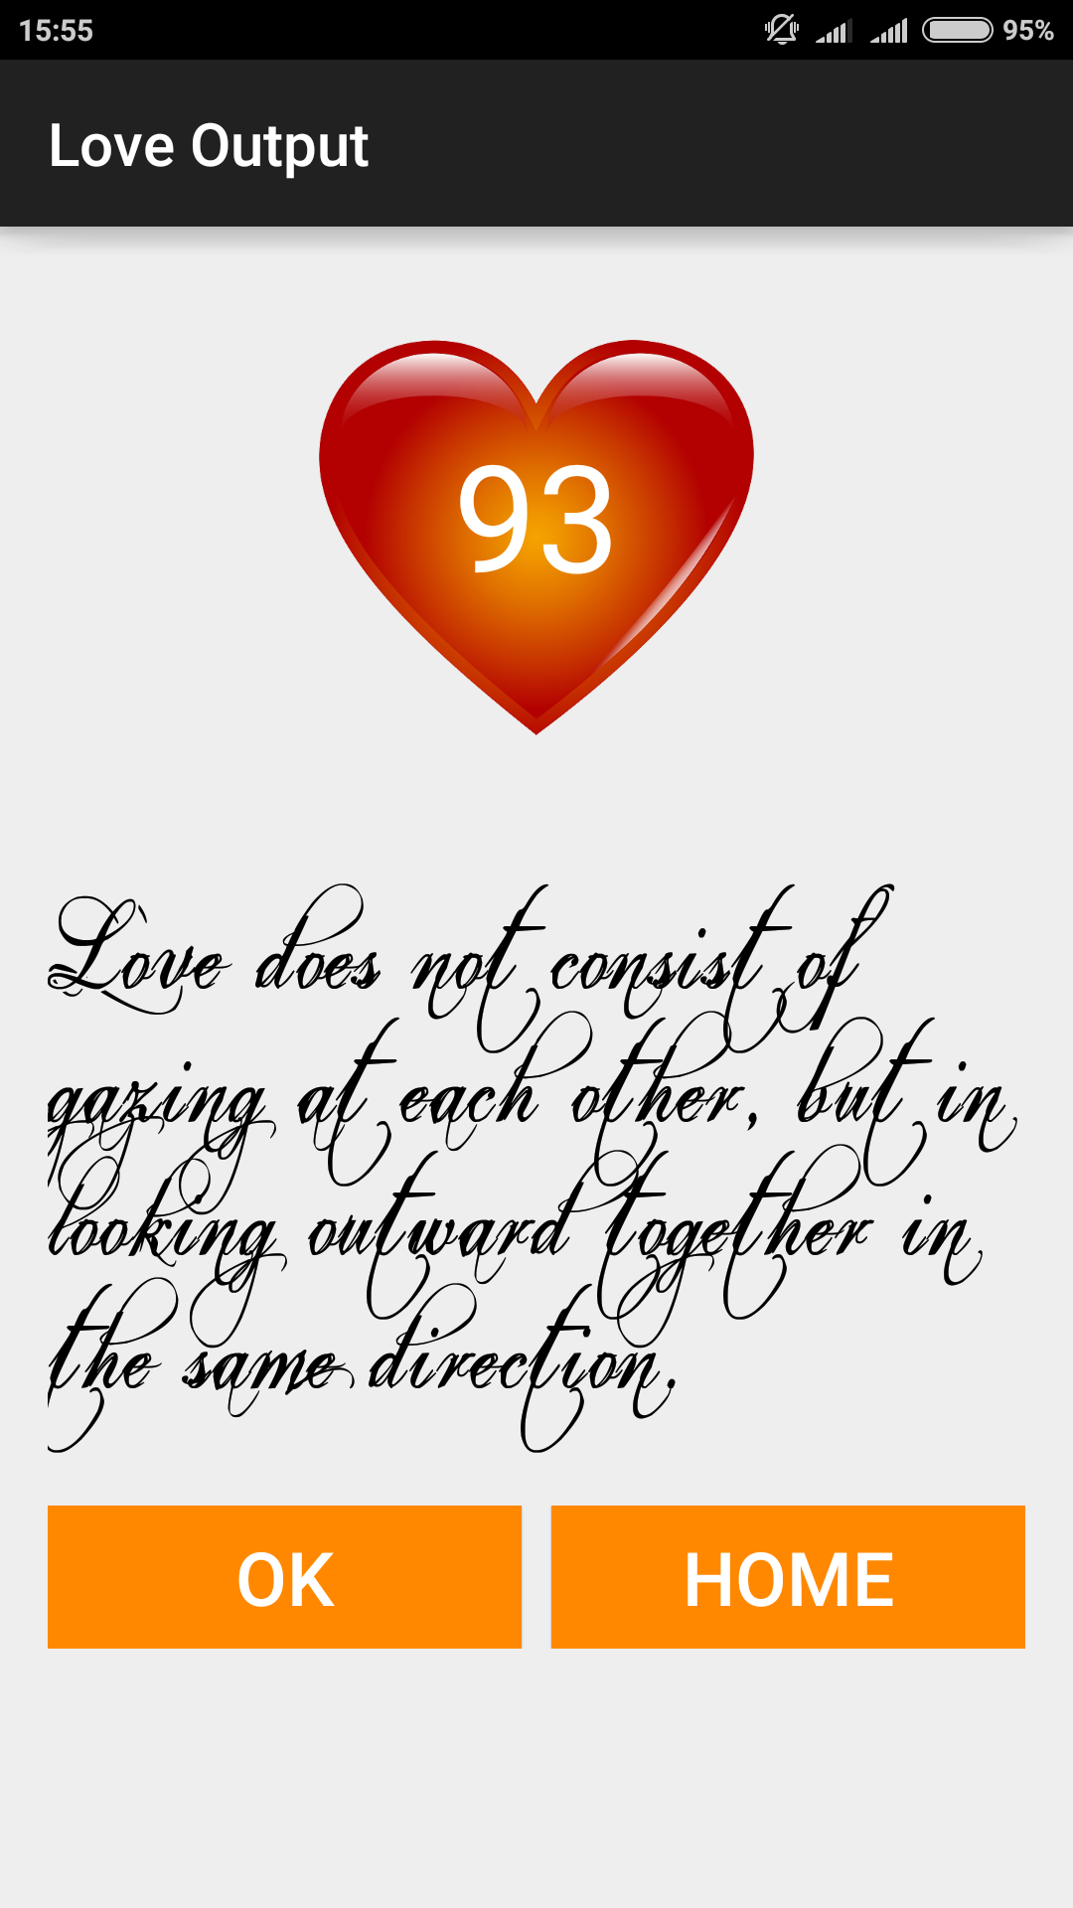

This page is the output of the love calculations which has custom fonts and two buttons to go back to love calculator or directly to the home page.

Interest Calculator

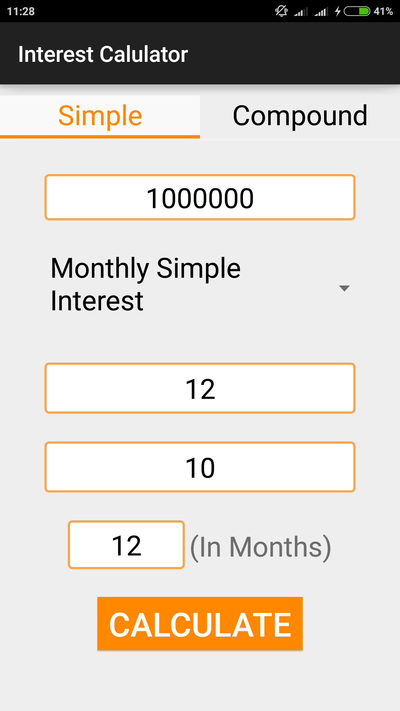

This page is of interest calculator which can be opened by clicking on the interest calculator button on the home screen. This calculator has two option simple and compound interest

Interest calculator Output Screen

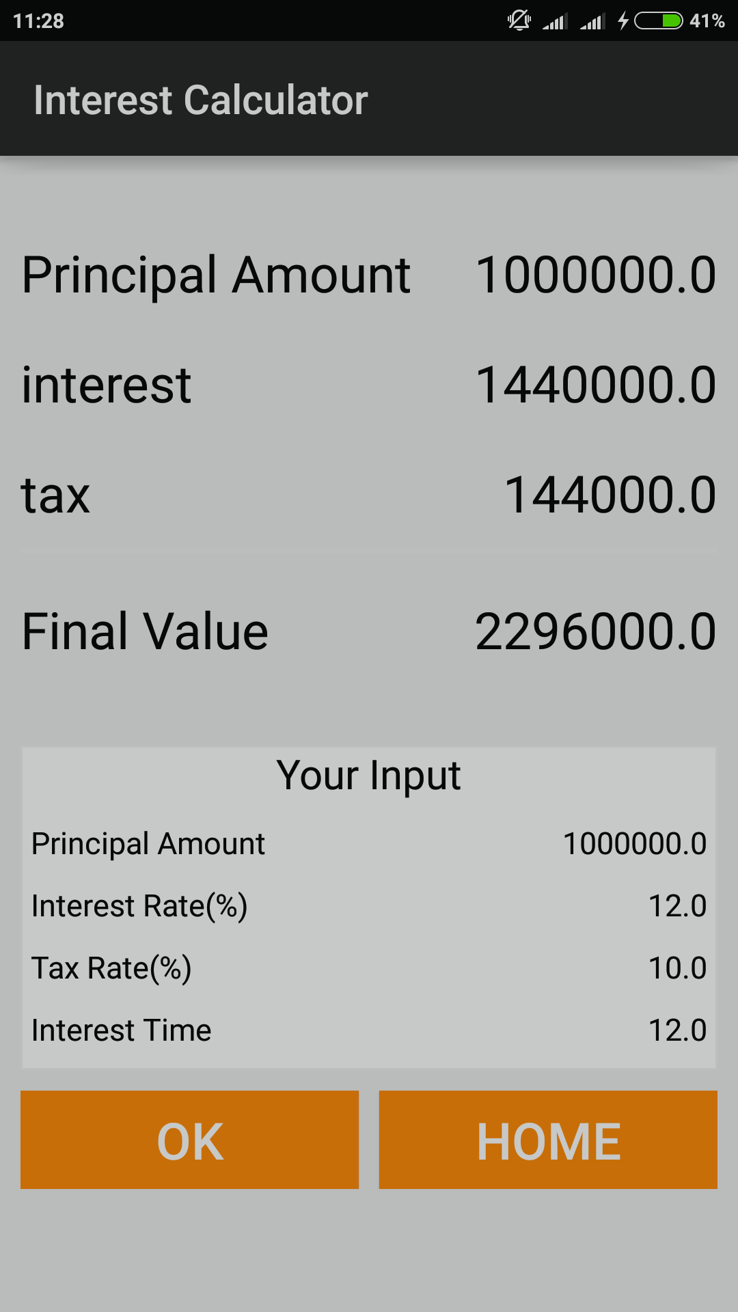

This is the output screen of the interest calculator which shows the calculated output and also shows the input values.

Mortgage Calculator Screen

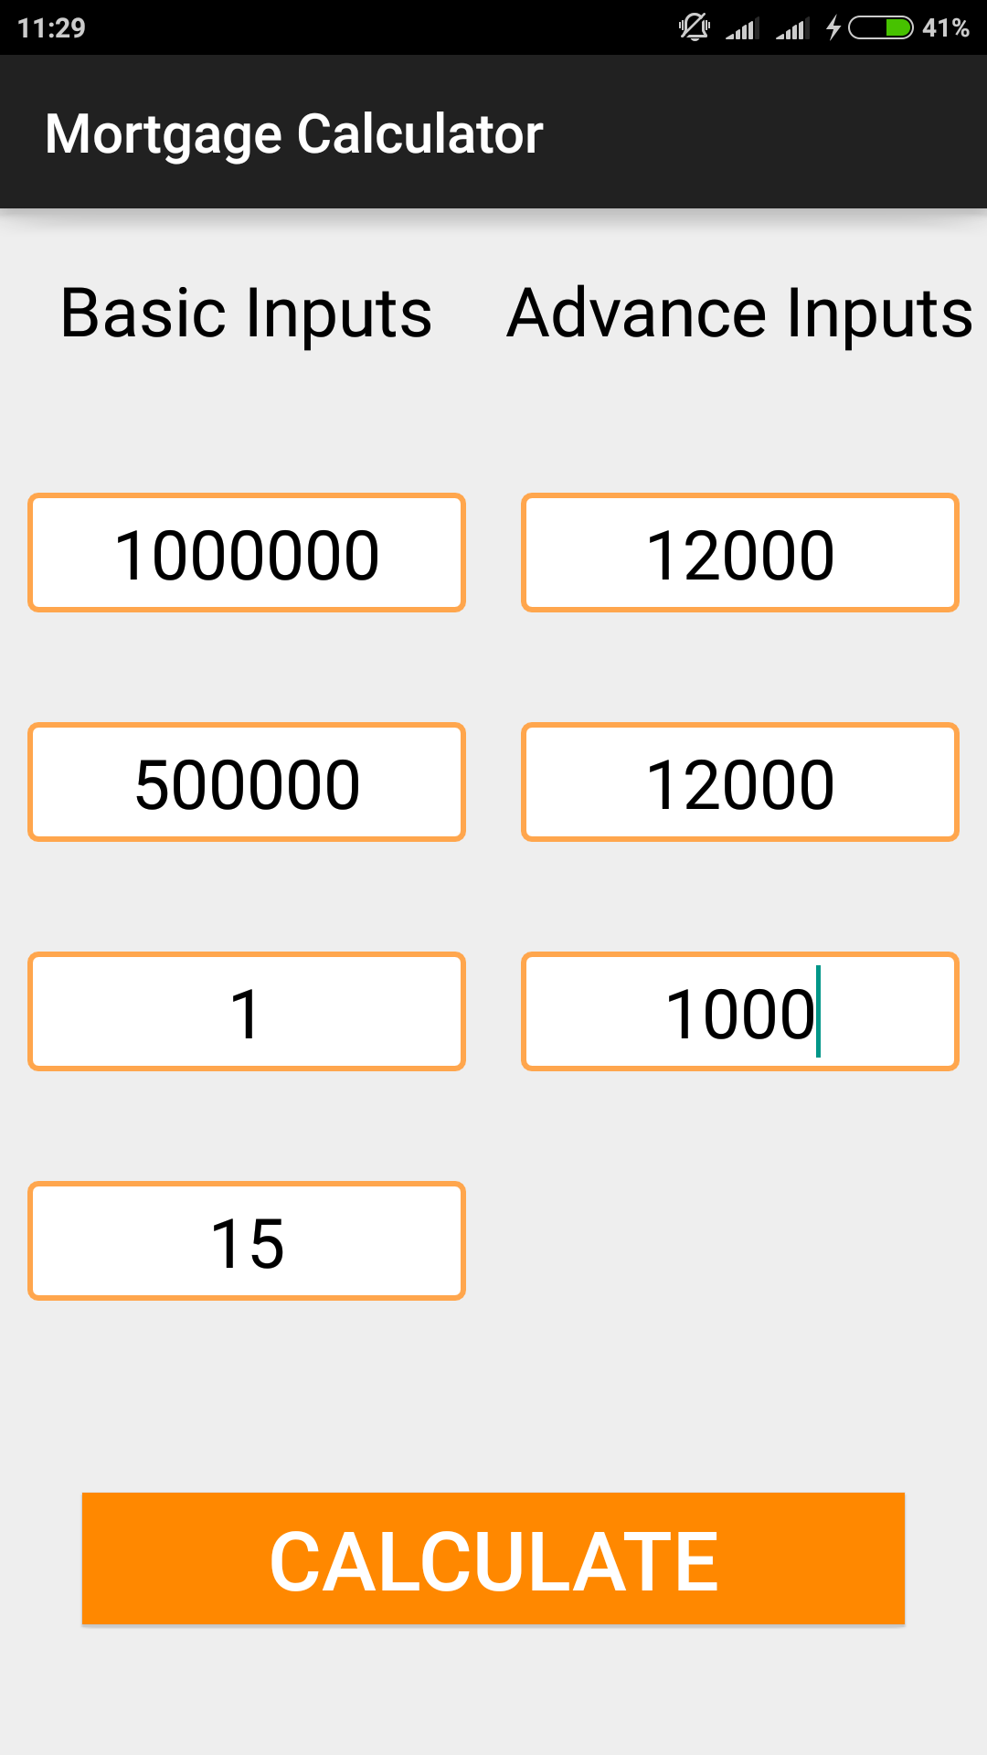

This page shows the layout of the mortgage calculator which can be opened by clicking on the mortgage calculator icon.

Mortgage Calculator Output Screen

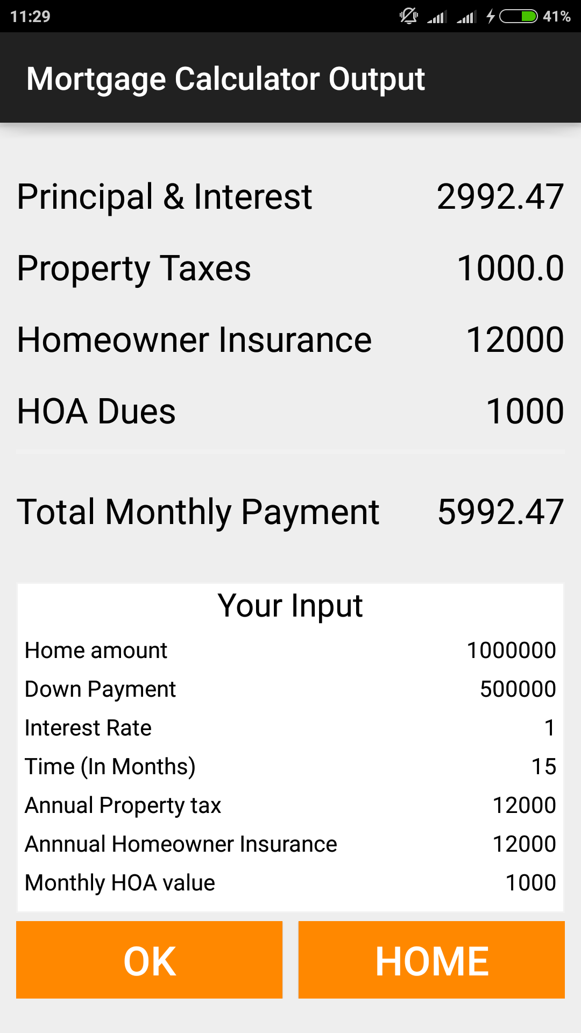

This is the output screen of the mortgage calculator which shows the calculated output and also shows the input values.

Convertor Home page

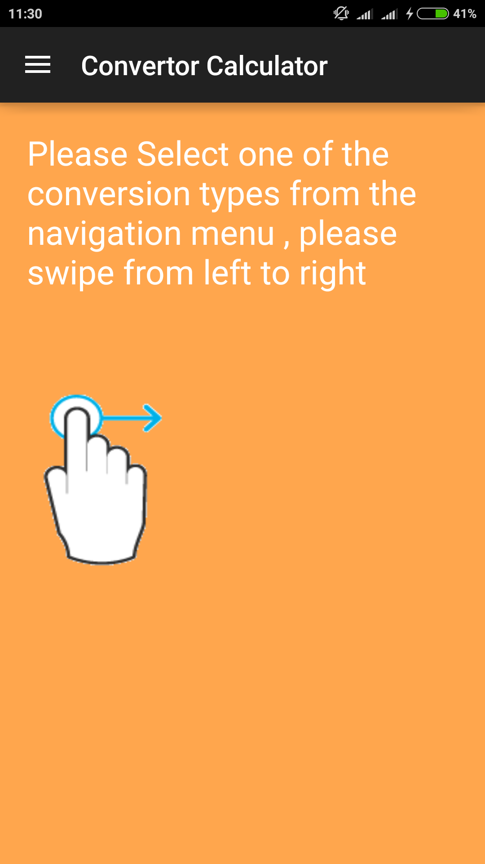

This is the main layout of the convertor which can be opened by clicking on the convertor icon in the home page.

Convertor Navigation Menu Screen

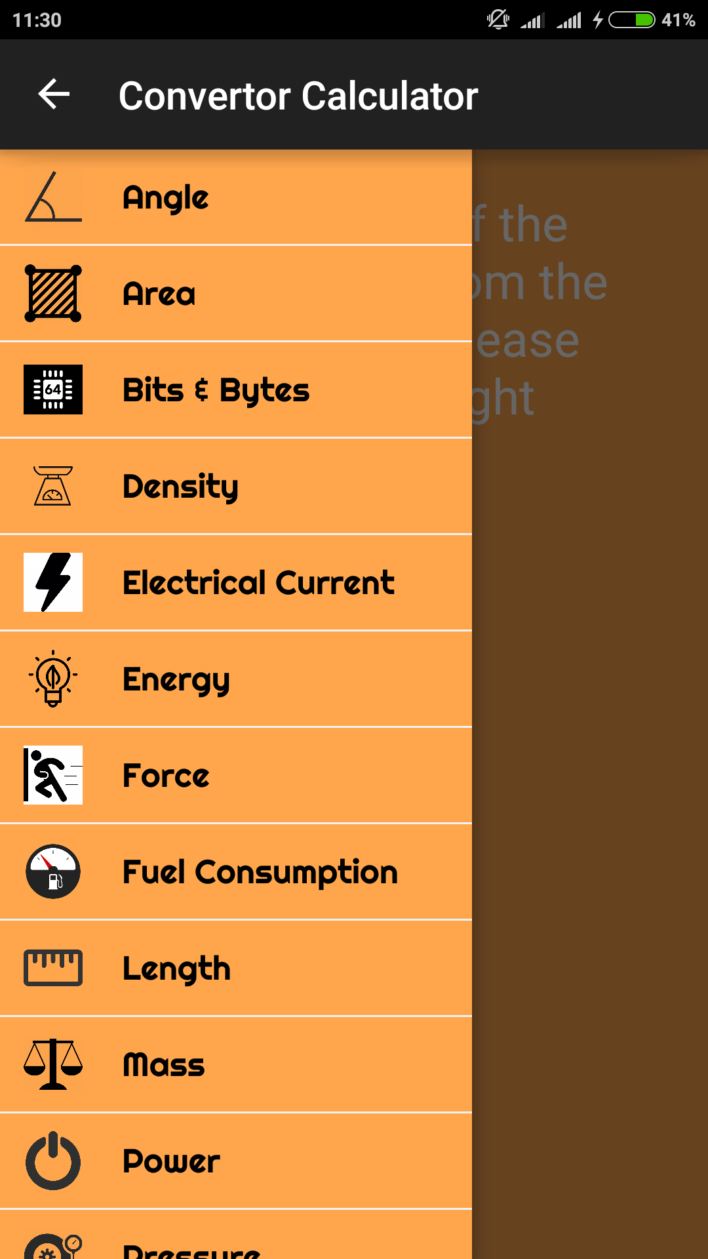

This is the convertor navigation menu which can be opened by swiping right to left or by clicking on the icon at the left had side of the title bar.

Convertor Navigation Menu Screen(Hindi)

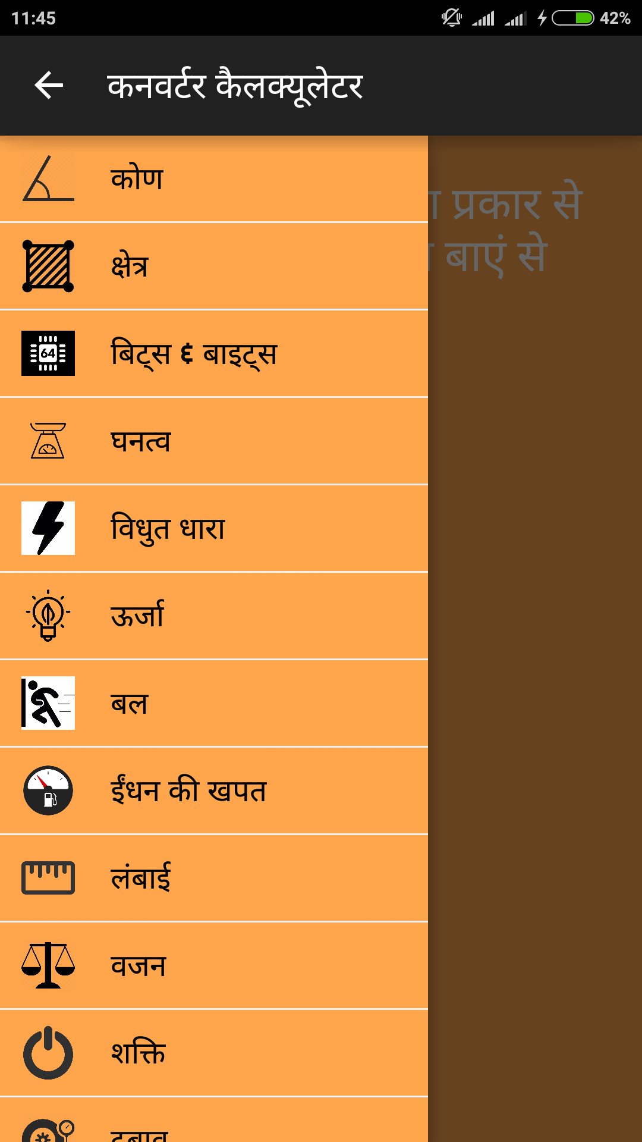

This is the same as above screen just the language selected is Hindi.

Convertor Main Page

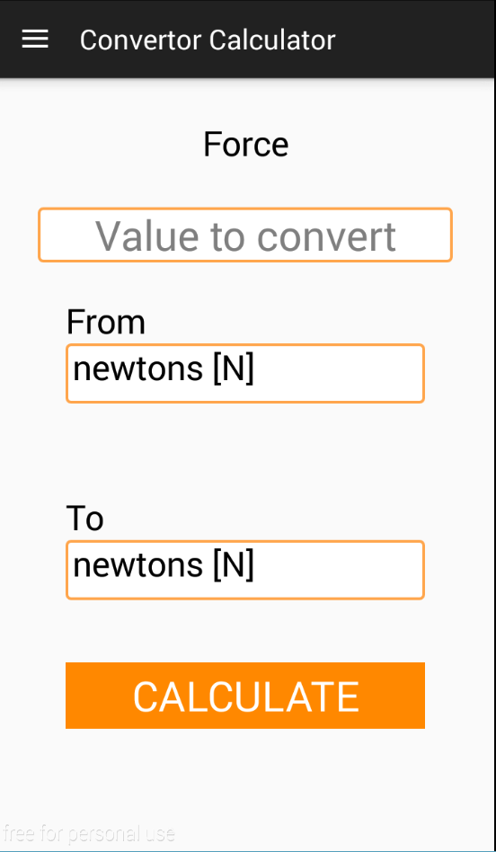

This page is the main page of the convertor which have drop down menu from which the conversion types has to be selected.

Health Calculator

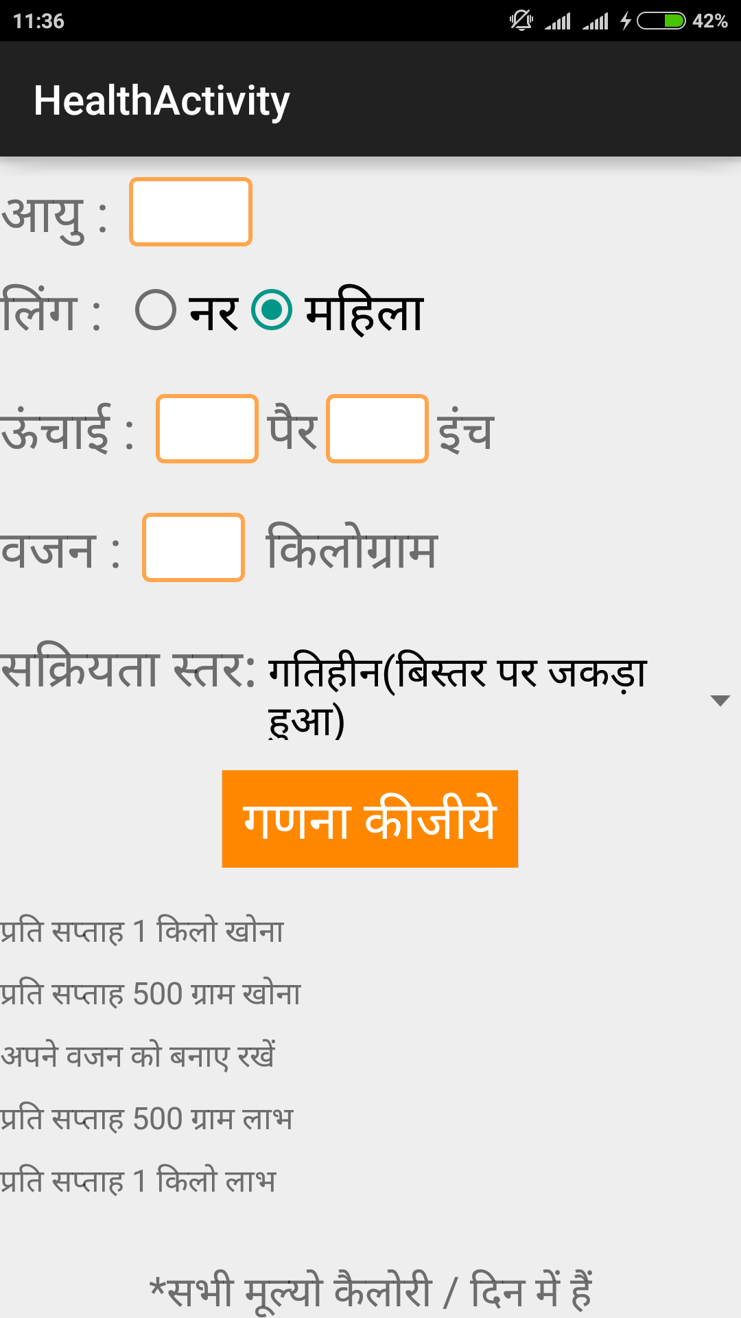

This is the main layout of the health calculator which can be opened by clicking on the health calculator icon from home page.

Health Calculator Output Screen

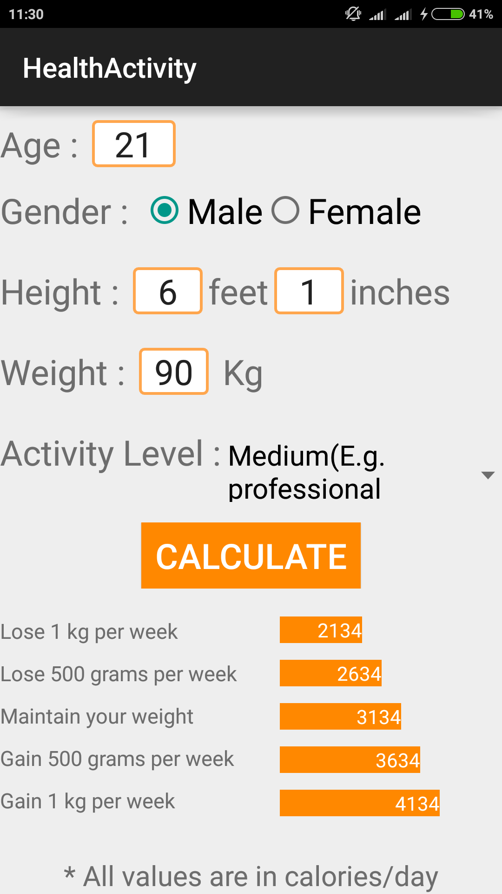

This page is the output layout of the health calculator, it is on the same page but the picture shows that the output is shown in the layout.

Time Calculator

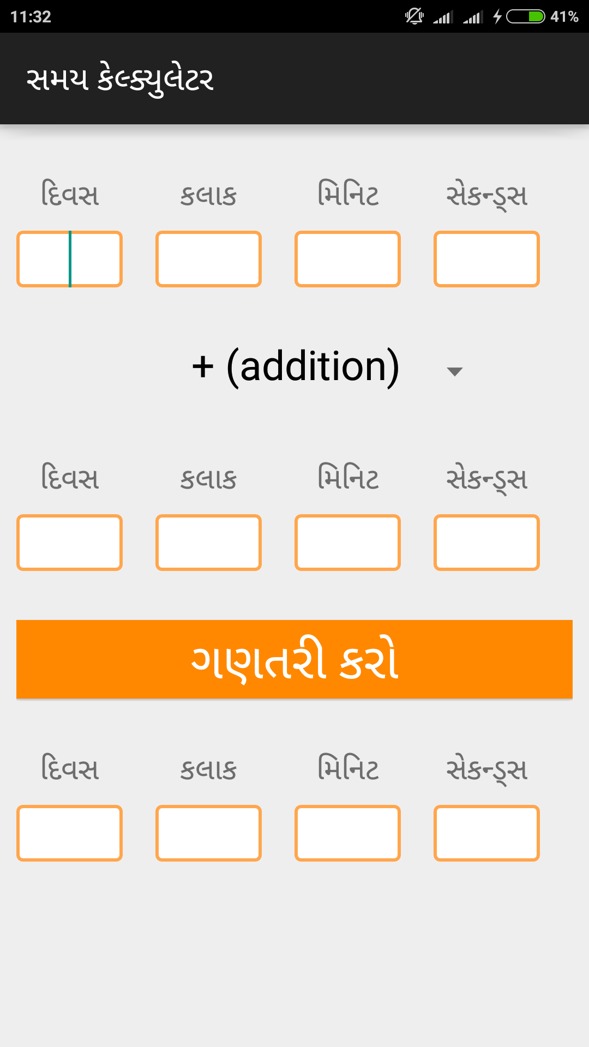

This page is of the time calculator which can be opened by clicking on the Time calculator icon on the home page.

Time Calculator Output Screen

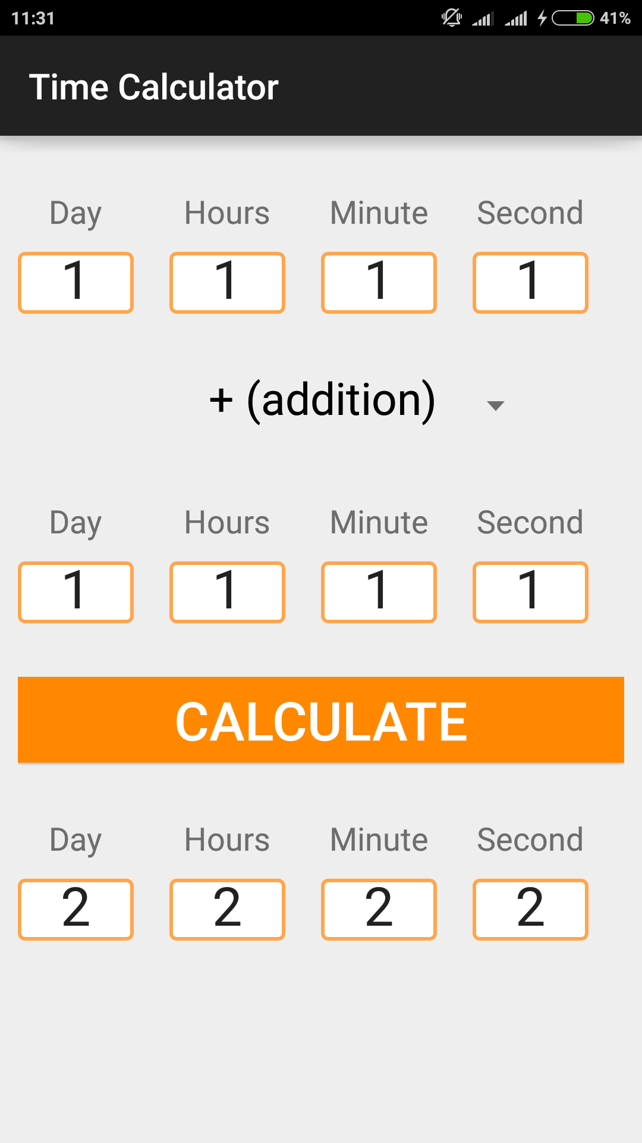

This layout is same as above but It shows the output of the time calculator, the boxes under the calculate button are non editable.